**Report about best devices & OS & programming languages & database and applications.**

**System Name:**

1. **Devices**

**Server: small server storage data for tasks use dell 730 server because small server.**

**Workstation: this suitable device for run web and manage all tasks for this.**

1. **Operating Systems**

**Linux: use this operating system for server because this operating system more secure to save data and use in servers**

**Windows: use this operating system for staff because suitable operating system and easy to use.**

1. **Programming Language**

Front end:

Use: html and CSS and bootstrap because easy to use for build web site

Backend:

Use: C# for build backend for behind code and easy to link framework asp.net (mvc)

1. **Database**

**SQL database:**

**SQL Server: use this database for relational database and best data base use to** framework asp.net (mvc) to link Microsoft.

1. **Applications**

**Application task: suitable app use in all system because to Website run all operating system hover this best application.**

**Design of an integrated system (Class diagram)**

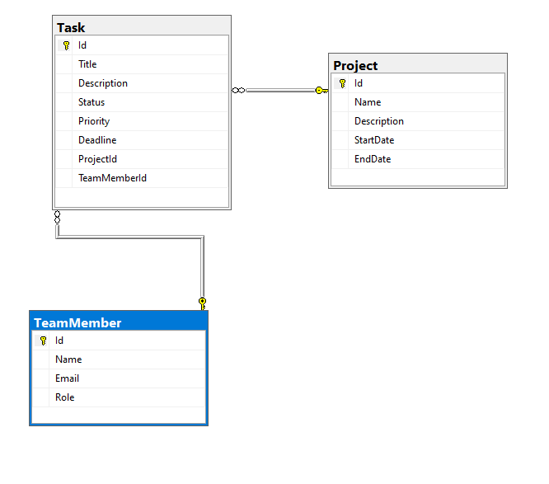

**Testing**

|  |  |  |  |  |  |  |
| --- | --- | --- | --- | --- | --- | --- |
| **Test case ID** | **Test case description** | **Test Steps** | **Test Data** | **Expected Result** | **Actual Result** | **Pass/Fail** |
| 1 | Add anything for form create to class projects | Enter valid data to create project | Project name : project1  ,description : project success  And all data | create | create | pass |
| 2 | Edit anything for from class projects | Enter valid data to edit project | Project name : project1122  ,description : project success side  And all data | edit | edit | pass |
| 3 | Delete anything for form class projects | Click button delete to delete this object from class projects | Project Id : 2 | delete | Delete | pass |
| 4 | Add anything for form create to class team members | Enter valid data to create project | Team members name : team1  ,email : team1@gmail.com  And all data | create | create | pass |
| 5 | Edit anything for from class team members | Enter valid data to edit project | Team members name : team15  ,email : team11@gmail.com  And all data | edit | edit | pass |
| 6 | Delete anything for form class team members | Click button delete to delete this object from class projects | team members Id : 2 | delete | Delete | pass |